
JOIN US IN THE CELEBRATION OF SPIRIT WEEK & THE BARNSTABLE RAIDERS VS THE FALMOUTH CLIPPERS FOOTBALL GAME FOR THE 5TH ANNUAL PARADE AND PEP RALLY!!
DATE: WEDNESDAY, NOVEMBER 27, 2013
TIME: 1:00 PM
LOCATION: MAIN STREET, HYANNIS!!
FOLLOWED BY THE ANNUAL PEP RALLY ON THE TOWN VILLAGE GREEN!
Please bring a new unwrapped toy to the Town Village Green for TOYS FOR TOTS so those in need can have a joyous season!
Sponsored by the Barnstable Quarterback Club
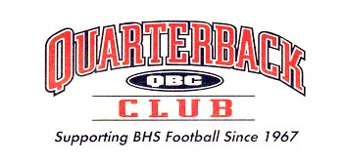
Barnstablefootball.com

